
MEMORANDUM

To: | Charlie Refvem, Department of Mechanical Engineering, Cal Poly SLO crefvem@calpoly.edu
From: | Colby Cordoba ccordoba@calpoly.edu  Hobbs Hegedus hhegedus@calpoly.edu
Date: | 2-22-2026
RE: | UI Design and Automated Data Collection

Assignment
In this lab, we were tasked with designing a serial-based user interface to tune and evaluate the closed-loop motor control system on the Romi robot. Building upon the PI motor controller developed in Lab 0x03, the system was extended to support automated step-response testing, runtime gain adjustment, and structured data logging for PC-side analysis.
The firmware is organized using a cooperative multitasking framework, where each subsystem (user interface, motor control, and data collection) runs as a scheduled task under the pri_sched() scheduler. Hardware initialization, shared variables, and inter-task queues are created in main.py, while all user interaction is handled by dedicated UI tasks to prevent blocking real-time motor and control execution.
Two user interface tasks are implemented: a tuning interface for entering controller gains and setpoints, and a data-collection interface for triggering step-response tests. The tuning interface accepts multi-character numeric input for proportional and integral gains as well as the desired speed setpoint. This input logic is adapted from the provided multichar_input.py example and integrated into the UI task to remain compatible with cooperative scheduling.
When step-response testing is initiated, control is passed to the data-collection interface, where the user can command left, right, or simultaneous motor tests, stop an active test, or return to the tuning menu. During testing, the UI is intentionally locked out while motor velocity data and timestamps are buffered using queues. Once the collection is complete, the data is printed in CSV format over the serial port.
After validating system operation using PuTTY, the interface is designed to be driven by a PC-side Python script. This script opens the serial port, sends the same single-character commands used during manual testing, captures the returned CSV data, saves it to timestamped files, and automatically generates step-response plots for analysis.

The file step_collector_loop.py automates step-response testing by acting as a “wrapper” around the interface. Instead of a human typing commands in PuTTY, the script opens the same serial port (COM9, 115200 baud) and transmits the same single-character commands and numeric entries. This allows repeated tests to be run consistently and data to be logged automatically for analysis and plotting.

Script Workflow
- Serial connection + synchronization
  - The script opens the serial port with a short timeout to keep reads responsive (TIMEOUT_S = 0.15).
  - Before sending any commands, the script drains the serial buffer to remove leftover startup messages or partial lines from previous runs, which helps prevent parsing errors later when converting data to CSV.
  - sync_to_tuning_ui() forces the system into a known state by:
    - Sending a couple carriage returns
    - Sending the h key to request the tuning banner/menu
    - Waiting until the banner text and prompt are detected
- Automatically setting controller gains and setpoint
  - set_gains_and_setpoint() drives the tuning UI exactly like a user would:
    - Sends k to enter gain-entry mode
    - Waits for “Enter proportional gain …” then sends kp + Enter
    - Waits for “Enter integral gain …” then sends ki + Enter
    - Sends s to enter setpoint mode
    - Sends setpoint_mm_s + Enter
  - Each step uses read_until_any() to block until the expected prompt appears (or times out), which prevents the script from “typing ahead” faster than the MCU can respond. This way we do not have to use delays as previously tried which greatly speed up the testing process.
- Running step response tests (left then right)
  - collect_step_response_single_side() performs one test on either l or r:
    - Sends g to enter the data-collection UI
    - Waits for confirmation that the user task is active
    - Sends l (left) or r (right) to start a step response
    - Waits for “Data collection complete …”
    - Waits until the prompt returns, meaning all CSV data has printed
    - Sends h to return cleanly back to the tuning interface
  - As configured, it runs left then right, so each dataset stays separate and legends/plots are clean.
  - The serial output is collected as raw text blocks (including headers, menus, and CSV). The script also saves a _raw.txt file containing the full unfiltered serial transcript for debugging if parsing fails.
    - parse_csv_from_text() is intentionally conservative:
      - It ignores everything until it sees the CSV header line containing Time [us]
      - Then it reads only lines of the form: <time>,<value>
      - It stops when it sees the footer (“Commands:” or dashed lines)
    - This ensures the script doesn’t accidentally treat UI banners or status messages as data.
- Unit conversion
  - Since the MCU prints time in microseconds, the script converts to seconds via:
    - t_s = t_us × 1e-6
  - That produces time vectors compatible with typical control plots and performance metrics.
- Output files and organization
  - The script creates a timestamped “Collection Log” directory and saves:
    - MM_DD_HH_MM_SS_left.csv
    - MM_DD_HH_MM_SS_right.csv
    - MM_DD_HH_MM_SS.png (combined plot with legend)
    - MM_DD_HH_MM_SS_raw.txt (full serial transcript)
    - Each CSV includes metadata headers (setpoint, Kp, Ki) so datasets remain traceable even when collected in bulk.
- Plotting and performance metrics
  - save_plot() plots left and right step responses on the same axes and draws a dashed horizontal line at the commanded setpoint. This provides an immediate visual check of rise behavior, overshoot, and steady-state tracking.
  - compute_step_metrics() estimates basic performance quantities per motor:
  - steady-state value y_ss (average of the last chunk of samples)
  - peak value y_pk and time of peak t_pk
  - percent overshoot relative to setpoint: $\%OS=\frac{y_{pk}-SP}{SP}×100\%$
  - These metrics are printed to the console for quick tuning feedback.

Task Scheduler
The program is organized as a set of cooperative, generator based tasks scheduled at a fixed rate. Each task has a single responsibility and communicates with other tasks using Share and Queue objects instead of direct calls, which keeps the system modular and prevents tight coupling between motor control, sensing, and the user interface.
- task_motor
  - Period: ~10 ms (100 Hz)
  - Priority: High
  - Reads the encoder every cycle and computes measured position and velocity, and publishes them through shares.
  - Applies the effort command to the motor driver.
  - Optionally logs data into queues for later printing.
  - The motor task must run consistently and predictably, so it should not be blocked by user I/O or printing.
- task_control / task_control_loop
  - Period: ~10 ms (same as motor task)
  - Priority: High (equal to motor task, or slightly lower but still above UI)
  - Closed-loop controller that computes the effort command.
  - When enabled, it reads the current setpoint and gains, reads measured speed (omega_meas), runs the PID math, and writes an effort command.
  - When disabled, it forces effort to zero.
  - It resets internal controller state on the rising edge of enable to prevent integrator windup and derivative spikes.
- task_user (data collection UI)
  - Period: ~50–100 ms
  - Priority: Low
  - Reads serial commands (l, r, b, x, h).
  - Starts a data collection run by setting “go” flags for the motors and clearing the appropriate queues.
  - After the buffers fill, it prints the stored time/data pairs as CSV
  - Serial printing is slow and unpredictable, so isolating it prevents it from interfering with real-time sensing/control.
  - task_tuning_ui (Implemented into task user)
    - Runs only when start_user == 0.
    - Updates Kp, Ki, setpoint.
    - Starts the data-collection UI by setting start_user = 1.

Table 1. Table of Shares and Queues
Variable Name | Data Stored | Written By | Read By | Purpose
motorLGo | Left motor enable flag (0/1) | task_user, task_tuning_ui | task_motor, task_control | Enables or disables the left motor and its control loop during testing.
motorRGo | Right motor enable flag (0/1) | task_user, task_tuning_ui | task_motor, task_control | Enables or disables the right motor and its control loop during testing.
setpoint | Desired reference speed (counts/s) | main, task_tuning_ui | task_control, task_user | Stores the user-entered speed command used by the controller.
Kp | Proportional gain | main, task_tuning_ui | task_control, task_user | Allows real-time tuning of proportional control action.
Ki | Integral gain | main, task_tuning_ui | task_control, task_user | Allows real-time tuning of integral control action.
omegaL | Left wheel velocity (counts/s) | task_motor | task_control, task_user | Transfers left encoder velocity measurement to the control loop and UI.
omegaR | Right wheel velocity (counts/s) | task_motor | task_control, task_user | Transfers right encoder velocity measurement to the control loop and UI.
effortL | Left motor effort command (%) | task_control | task_motor | Communicates the controller output to the left motor driver.
effortR | Right motor effort command (%) | task_control | task_motor | Communicates the controller output to the right motor driver.
start_user | UI ownership flag (0 = tuning UI, 1 = data UI) | main, task_tuning_ui | task_user | Determines which UI task has control of the serial interface.
posL | Left encoder position (counts) | task_motor | main, task_user | Provides left position data for logging and plotting.
posR | Right encoder position (counts) | task_motor | main, task_user | Provides right position data for logging and plotting.
dataValuesL | Left motor speed samples (counts/s) | task_motor | task_user | Buffers left motor step-response velocity data for CSV printing.
timeValuesL | Left motor timestamps (µs) | task_motor | task_user | Stores elapsed time values aligned with left speed samples.
dataValuesR | Right motor speed samples (counts/s) | task_motor | task_user | Buffers right motor step-response velocity data for CSV printing.
timeValuesR | Right motor timestamps (µs) | task_motor | task_user | Stores elapsed time values aligned with right speed samples.

Table 2. Table of Shares and Queues
Task name | Period (ms) | Priority
task_motor_L | 10 | 2
task_control_L | 10 | 2 (or 1)
task_motor_R | 10 | 2
task_control_R | 10 | 2 (or 1)
task_user | 50–100 | 0
task_tuning_ui | 50–100 | 0

All tasks ran on time according to the scheduler profiler, with the motor and control tasks consistently meeting their assigned periods and showing no deadline misses. These tasks were given higher priority and shorter periods to ensure stable closed-loop control and accurate encoder updates. The user interface tasks were assigned lower priority and longer periods since serial communication and printing are slower and not time-critical. This priority structure successfully protected the real-time control loop from being disrupted by UI activity, producing the intended behavior of reliable motor control alongside functional data collection and printing.

While planning the overall software architecture, state transition diagrams and task interaction diagrams were created to visualize how the system operates and how different tasks communicate with one another. The state diagrams (Figures 1, 2, and 3) illustrate the internal behavior of individual tasks, showing how each task transitions between states in response to user input, control flags, and system conditions. The task interaction diagram provides a higher-level view of the system, highlighting how data is passed between tasks through shared variables and queues under the cooperative multitasking scheduler. Together, these diagrams were used to guide implementation, verify correct task coordination, and ensure that real-time motor control was not blocked by user interaction or data logging.
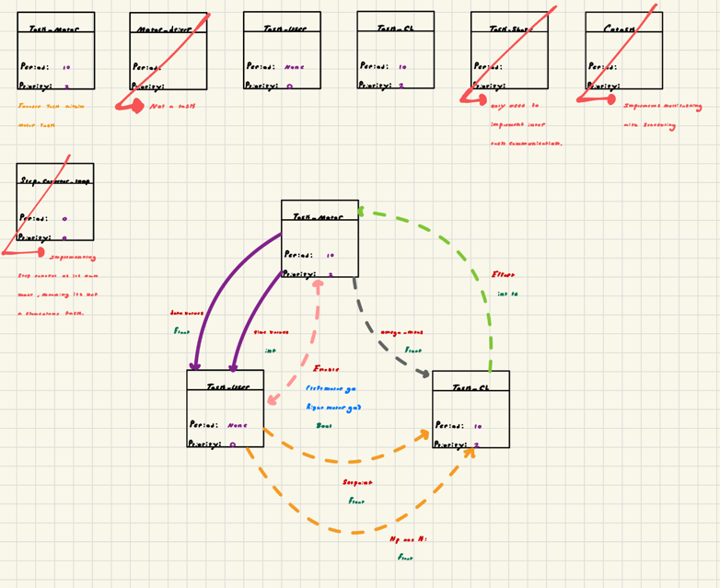
Figure 1. Task Diagram

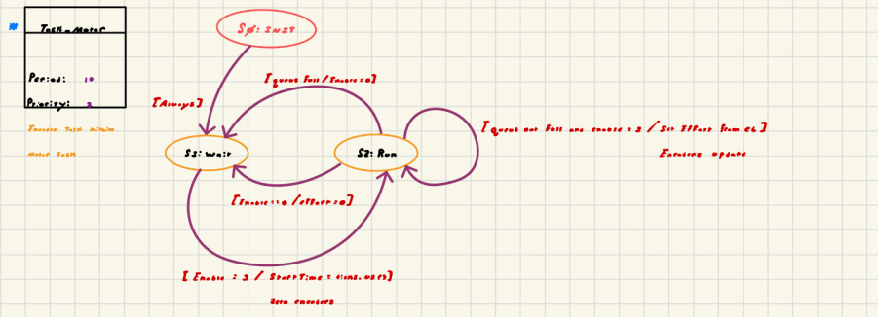
Figure 2. Task Motor FSM
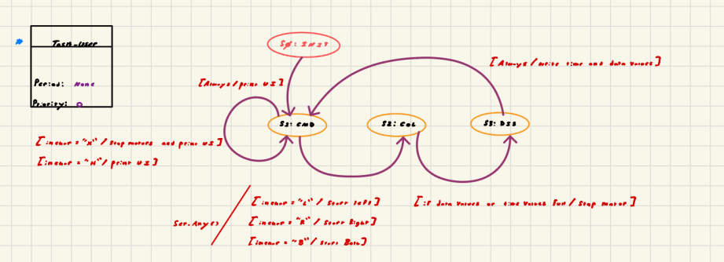
Figure 3. Task User FSM
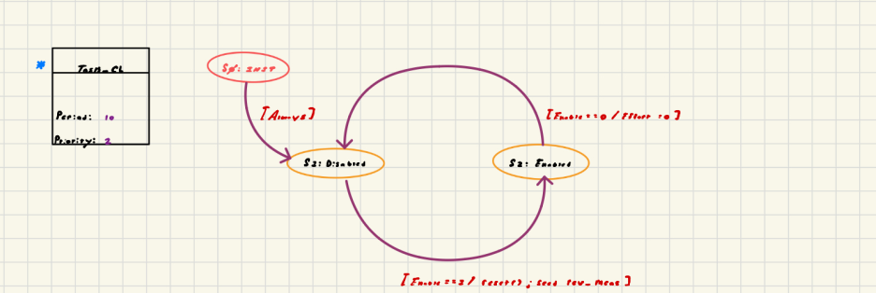
Figure 3. Task Closed Loop FSM

Plots
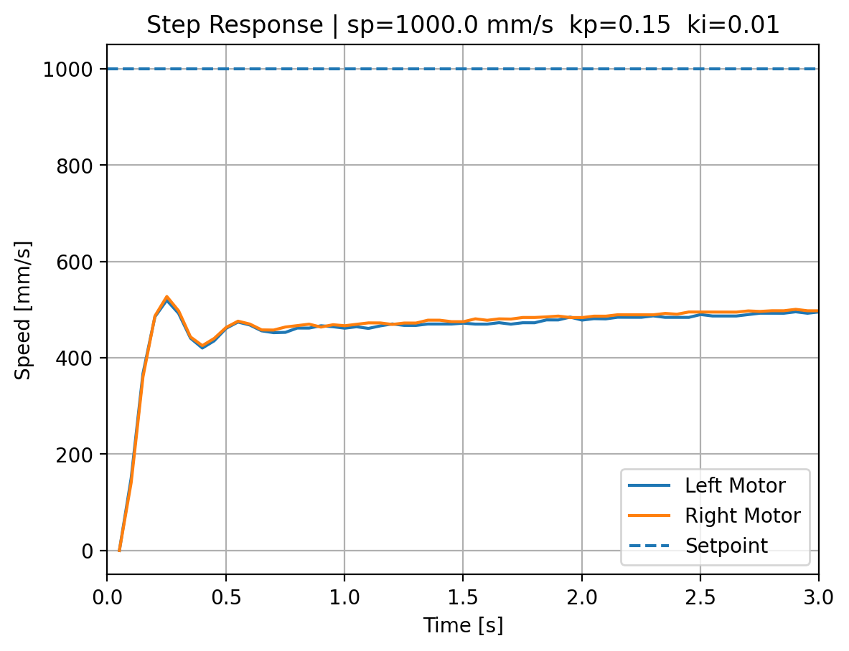
Figure 3. Step Response: Test 1
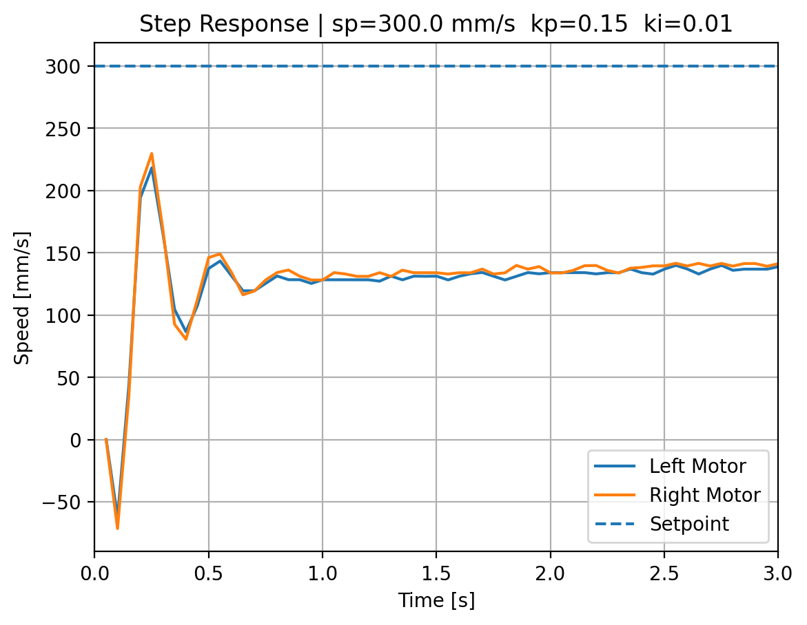
Figure 4. Step Response: Test 2

The step response plots generally demonstrate the expected behavior of a closed-loop second-order system. In both tests, the motors exhibit a clear transient response characterized by an initial rise, overshoot, and damped oscillations before settling toward a steady-state value. This confirms that the proportional–integral controller is producing the anticipated dynamic behavior.
However, a consistent discrepancy is observed between the commanded setpoint and the achieved steady-state motor speed. In both cases, the steady-state velocity settles at approximately half of the desired setpoint value. This suggests a systematic scaling issue rather than random error. A likely cause may be a unit conversion mismatch, or an error in how the setpoint is interpreted relative to the measured velocity. However, I believe that our batteries were low on power unfortunately which lead to our half-powered system. Despite this steady-state offset, the overall response shape clearly reflects second-order dynamics with visible overshoot and damping, meeting the qualitative behavior expected for the system.

References:
ME 405 Class Notes
Chat GPT

Main
from motor_driver import motor_driver
from encoder import encoder
from task_motor import task_motor
from task_user import task_user, task_tuning_ui
from task_share import Share, Queue
from cotask import Task, task_list
from task_control_loop import task_control
from gc import collect
import pyb

# -----------------------------
# USB
# -----------------------------
ser = pyb.USB_VCP()
ser.write(b"\r\n*** main.py started ***\r\n")
pyb.delay(50)

# -----------------------------
# Hardware setup
# -----------------------------
PWM_FREQ = 20000
tim4 = pyb.Timer(4, freq=PWM_FREQ)

pwmL = tim4.channel(4, pyb.Timer.PWM, pin=pyb.Pin('PB9'))
pwmR = tim4.channel(3, pyb.Timer.PWM, pin=pyb.Pin('PB8'))

motorL = motor_driver(pwmL, 'PC0', 'PC1')
motorR = motor_driver(pwmR, 'PC2', 'PC3')

encL = encoder(2, 'PA0', 'PA1')
encR = encoder(1, 'PA8', 'PA9')

# -----------------------------
# Shares
# -----------------------------
motorLGo = Share("B", name="Left Enable")
motorRGo = Share("B", name="Right Enable")

setpoint = Share("f", name="Setpoint")
Kp = Share("f", name="Kp Gain")
Ki = Share("f", name="Ki Gain")

omegaL = Share("f", name="Omega L")
omegaR = Share("f", name="Omega R")

effortL = Share("h", name="Left Effort")
effortR = Share("h", name="Right Effort")

start_user = Share("B", name="Start User Task")

posL = Share("l", name="Pos L")
posR = Share("l", name="Pos R")

# -----------------------------
# Initial values
# -----------------------------
motorLGo.put(0)
motorRGo.put(0)

setpoint.put(1200.0) # counts/sec
Kp.put(0.02)
Ki.put(0.0)

effortL.put(0)
effortR.put(0)

start_user.put(0) # tuning UI will set this to 1

# -----------------------------
# Queues
# -----------------------------
dataValuesL = Queue("f", 100, name="Left Data Buffer")
timeValuesL = Queue("L", 100, name="Left Time Buffer")

dataValuesR = Queue("f", 100, name="Right Data Buffer")
timeValuesR = Queue("L", 100, name="Right Time Buffer")

# -----------------------------
# Motor tasks
# -----------------------------
leftMotorTask = task_motor(
motorL,
encL,
motorLGo,
effortL,
posL,
omegaL,
dataValuesL,
timeValuesL
)

rightMotorTask = task_motor(
motorR,
encR,
motorRGo,
effortR,
posR,
omegaR,
dataValuesR,
timeValuesR
)

# -----------------------------
# Control tasks
# -----------------------------
def cl_left():
yield from task_control(
motorLGo,
setpoint,
Kp,
Ki,
omegaL,
effortL
)

def cl_right():
yield from task_control(
motorRGo,
setpoint,
Kp,
Ki,
omegaR,
effortR
)

# -----------------------------
# UI tasks
# -----------------------------
tuningTask = task_tuning_ui(
start_user,
setpoint,
Kp,
Ki,
ser=ser
)

userTask = task_user(
start_user,
motorLGo,
motorRGo,
dataValuesL,
timeValuesL,
dataValuesR,
timeValuesR,
setpoint,
Kp,
Ki,
ser
)

# -----------------------------
# Scheduler
# -----------------------------
task_list.append(Task(leftMotorTask.run, name="Left Motor", priority=1, period=50))
task_list.append(Task(rightMotorTask.run, name="Right Motor", priority=1, period=50))

task_list.append(Task(cl_left, name="Left Control", priority=2, period=50))
task_list.append(Task(cl_right, name="Right Control", priority=2, period=50))

task_list.append(Task(tuningTask.run, name="Tuning UI", priority=0, period=50))
task_list.append(Task(userTask.run, name="User", priority=0, period=50))

collect()

# -----------------------------
# RUN
# -----------------------------
while True:
try:
task_list.pri_sched()
except KeyboardInterrupt:
motorL.disable()
motorR.disable()
print("Program Terminated")
break
*Files cotask and task_share from John Ridgley also required
Please see the main code below as evidence that our program meets the objectives described above. Included is the output from a representative test run, along with a copied excerpt of the serial scroll back from our user interface. While the raw terminal output may appear cluttered, it reflects the received (RX) data being echoed from PuTTY into a text log, which was then processed and plotted. For clarity, a corresponding CSV file generated from the same test is also provided below.
Starting data-collection UI...
User task active.
Commands: l=left, r=right, b=both, x=stop, h=menu
L
Setpoint: 300.0 mm/s
Kp: 0.15 (%·s/mm)
Ki: 0.01 (%/mm)
50890,0.0
101258,91.79771
150885,180.6305
201264,183.8578
250934,144.4083
301393,100.6694
351071,93.2318
400772,108.2387
451230,130.2729
500952,132.2146
551428,124.3169
601162,120.154
650908,117.136
701403,124.2603
751158,126.1109
800920,126.0983
851431,124.2209
901199,126.0805
950972,126.0679
1001497,124.1889
1051281,126.0375
1101068,129.0306
1150864,132.0181
1201420,127.0754
1251234,128.9658
1301097,128.8391
1350931,131.9174
1401518,129.9432
1451365,128.8856
1501222,131.8459
1551083,131.8354
1600949,134.8262
1650818,131.8089
1701440,129.8508
1751318,134.7857
1801202,134.7748
1851090,134.7559
1900983,131.7534
1950877,134.7478
2001525,138.6303
2051430,137.7091
2101344,134.6884
2151262,134.6803
2201179,134.6803
2251105,137.6484
2301072,137.5355
2351018,137.6098
2400964,137.5933
2450910,137.5961
2500865,137.5685
2551591,138.4445
2601574,137.4942
2651561,140.4691
2701554,137.4639
2751551,137.4529
2801552,140.4298
2851561,143.3976
2901568,143.4005
2951581,140.3961
3001597,137.4007
3051619,140.3708
3100900,139.4586
3150929,143.3345
3200960,143.3288
3250998,140.3288
3301086,140.1831
3351136,143.2773
3401190,143.2658
3451245,146.2505
3501310,143.2343
3551374,143.2372
3601446,143.2143
3651518,143.2143
3701599,146.1746
3750935,145.3538
3801021,146.1571
3851113,143.1543
3901208,146.1308
3951311,146.1104
4001416,143.1171
4051523,146.0987
4101635,146.0812
4151002,148.2888
4201123,146.0579
4251246,143.0629
4301413,145.924
4351548,148.9941
4401689,148.9733
4451089,148.1988
4501238,145.9676
4551391,145.9618
4601547,148.9317
4650964,148.1388
4701132,148.8991
4751299,151.871
4801475,148.8694
4851653,148.8723
4901091,151.1009
4951276,148.8397
5001469,151.7953
Starting data-collection UI...
User task active.
Commands: l=left, r=right, b=both, x=stop, h=menu
R
Setpoint: 300.0 mm/s
Kp: 0.15 (%·s/mm)
Ki: 0.01 (%/mm)
51046,0.0
100824,95.88602
150604,189.0676
201141,183.2866
250928,138.0327
300726,96.00735
350531,92.98656
401097,121.1457
450925,140.9287
500756,137.9081
550592,122.9131
601188,115.1633
651051,122.849
700914,128.8365
750783,128.8184
800653,128.8107
850530,125.805
901199,129.7355
951086,128.7719
1000973,128.7745
1050866,131.7508
1100764,128.7487
1150667,131.7218
1200579,128.7074
1251239,132.7076
1301158,128.6894
1351085,131.6611
1401009,131.669
1450945,131.6452
1500881,128.6456
1550836,131.5925
1600789,134.586
1650745,131.5846
1700729,131.5399
1750716,134.4917
1800707,134.481
1850704,134.4675
1900748,131.3506
1950752,134.4487
2000761,134.4353
2050771,137.4145
2100785,140.3905
2150804,134.4084
2200827,134.3976
2250861,134.3654
2300898,140.326
2350937,137.3403
2400978,137.3321
2451027,137.3101
2501075,137.3101
2551135,140.2671
2601194,137.2827
2651261,140.2419
2701327,140.2503
2750654,136.2913
2800734,140.2111
2850814,143.1943
2900944,143.0458
2951040,140.1663
3001137,140.1607
3051235,140.1551
3101335,140.1523
3150699,145.2743
3200810,146.0842
3250932,143.0743
3301055,140.0852
3351185,143.0486
3401316,146.0259
3450707,145.192
3500843,143.0286
3550985,140.0405
3601129,145.9851
3651280,142.9859
3700691,148.1568
3750850,145.9473
3801013,142.9574
3851185,145.9007
3901394,145.799
3950826,145.0715
4001009,145.8775
4051198,145.8542
4101385,148.8397
4150836,145.0217
4201034,148.8041
4251244,148.7715
4300708,147.995
4350922,148.7715
4401138,145.7671
4451362,145.7555
4500842,150.9696
4551073,148.7093
4601309,151.6684
4650799,150.9391
4701043,148.6709
4751290,145.6859
4800793,150.8994
4850391,149.513
4900639,154.5931
4950992,151.3761
5000599,150.6286

